Pedal In the Park
The hazards below have been identified as influencing the safety of an event. Please complete the section below with details of likely hazards for your particular event/s.

Hazard | Control Measures
Riders’ equipment, health and stamina | Riders sign a disclaimer on the entry form agreeing to their fitness to take part in the event and that their cycle are in a safe, legal and rideable condition.  Tandem captains should be tandem trained. All C4AS representatives must read the event risk assessment before hand. Participants should be advised of any particular risks the event entails.  All cycle incidents must be record on the incident form by a C4AS representative.
Adverse weather | Riders should be warned at the start about any likely adverse weather i.e. ice/snow/fog etc and encouraged to wear appropriate clothing and ride accordingly.  If the weather conditions are wet, icy or windy this event should not be attempted.
Other road users / trail users | Events should take place away from busier roads where possible. Riders are reminded on the entry form that it is their responsibility to carry out manoeuvres safely and to adhere to the rules of the road.
Highway design or maintenance | The route should be risk assessed and any particular hazards pointed out on the entry form or route sheet. Hazardous features should be avoided if possible or alternatives given. However, riders must not be given the impression that the organisers can control what happens on public roads. See below risk assessment.
Other hazards | Risk assess and list any additional control measures separately below.

EVENT NAME: Cycling4All, Shropshire – ‘Pedal in the Park

EVENT Base: St Julian’s Friars, Shrewsbury

EVENT ROUTE: The route follows part of the NCN Route 81, from Porthill bridge to the weir.

DATE: ORGANISERS: Jean Breakell.

EVENT TYPE: Pedal In the Park Tandems captained by C4AS, representatives.

THE RISK ASSESSMENT FOR THIS EVENT MUST BE REVIEWED AT LEAST ONCE A YEAR, next 2nd April 2026.

RIDER LEADERS n/a.

GROUP BACK MARKER n/a.

ESTIMATEDPARTICIPANTS. 20

FIRST AIDER to be identified for each event.

SUPERVISORS / CARERS to be identified for each event as required
GUARDIANS

NOTES A mixture of cyclists on tandems and others riding solo on differing types of cycles
such as mountain bikes, hybrids, road cycles, three wheelers and electric bikes.

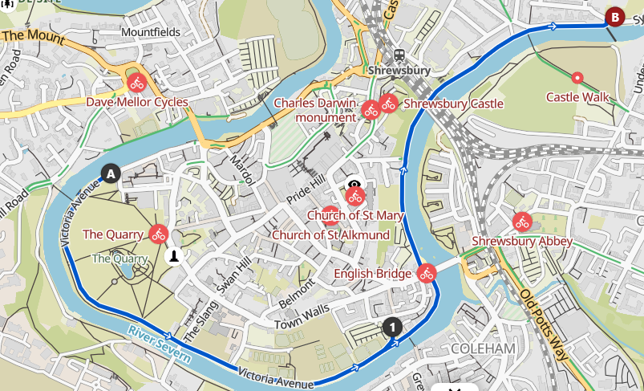

Traffic Free route suitable for Pedal In the Park, base situated at 1.

Hazard | Risk  (low = 1, medium =2, high = 3) |  | Severity of outcome (low = 1, medium =2, high = 3) | Total grade of hazard (= risk x severity). NB if total is 9, hazard must be removed or avoided | Location |  | Warning, Control measures and/or alternatives considered
Rider’s health/SN/Disability/  inexperience | 2 |  | 3 | 6 |  |  | Close support by able bodied riders (1 to 1 if necessary).  Use of suitable adaptive bikes and tandems. Matching of riders to bikes in advance of ride.  Mobile phones and first aid carried. Helmets and hi viz to be worn by all.
Equipment/bike safety | 2 |  | 3 | 6 |  |  | Cycles will be selected according to the rider’s height, weight and abilities and saddle heights will be adjusted appropriately. Tyres will be assessed to ensure adequate and even pressure. Use of suitable adaptive bikes and tandems.  Mobile phones and first aid carried. Helmets and hi viz to be worn. ‘M’ checks before starting.
Damage from gazebo and standing equipment | 1 |  | 2 | 2 | Greyfriars |  | Gazebo to be erected and dismounted with regard to passing pedestrians and cyclists and weighted down to avoid wind damage. Gazebo and standing equipment sited to avoid blocking the path through to the Quarry. Trip hazards to be avoided.
Rider going too fast | 2 |  | 3 | 6 |  |  | C4AS supervision to ensure speed restrained.
Traffic free cycle route shared with other cyclists, walkers and dog walkers travelling in both directions. Potential for collision. | 2 |  | 2 | 4 |  |  | Ride safety briefing given before start. Advised to share with care. Pedestrians to be given priority. Close supervision by C4AS. No significant hills.  Stop to avoid collisions if the route becomes crowded.
Nearby river. | 1 |  | 3 | 3 |  |  | C4AS representatives to closely supervise and take a route well clear.  Emergency buoyancy aids are located at intervals along the river.
facilities – toilets, cafes, shops. | 1 |  | 3 | 3 |  |  | Alternatives in place.
Cobbled stones under Shrewsbury train station bridge. | 2 |  | 3 | 6 | Railway bridge |  | Do not cycle when wet or icy.
Tree branches and brambles. | 2 |  | 2 | 4 |  |  | Stop and remove branches from cycle way. Avoid cycling over brambles to avoid punctures.
The cycle way under the English Bridge has a low arch warning. | 2 |  | 2 | 4 | English Bridge |  | Be observant of the arch and other users of the passage.
Wildlife | 1 |  | 2 | 3 |  |  | Wildlife such as ducks and swans live along the route. Avoid or stop to walk around them
Post and bollards | 2 |  | 2 | 4 |  |  | There are a number of post and bollards. Be very mindful and observant. Navigate around.
Tight bends | 2 |  | 3 | 6 |  |  | The route has some tight bends. Ride single file, slowly with care. Use bell to warn approaching.
Pot holes | 2 |  | 3 | 6 |  |  | Avoid or walk over.
Wet leaves | 2 |  | 3 | 6 |  |  | Slippery surface. Avoid, cycle with care or walk over.
Tarmac or paving edges. | 2 |  | 3 | 6 |  |  | Avoid, cycle with care or walk over.
Dark shaded areas and glare. | 2 |  | 3 | 6 |  |  | Be mindful of dark shaded areas even on a bright sunny day. Sun glare through the trees is also an issue. Be observant and take care. Walk if necessary.
The route has short ascent and descents. | 2 |  | 3 | 6 |  |  | Take care and choose the appropriate cycle gear before you approach the change in gradient.
Puddles | 2 |  | 2 | 4 |  |  | Avoid or take care.
Railings | 2 |  | 2 | 4 | Along river |  | The route has railings particularly along the river. Be mindful and observant of them.
Walls | 2 |  | 2 | 4 | Along river |  | Along the river are high brick walls. Avoid cycling to close to them as surfaces can be uneven and have protrusions
Cold, hot and wet weather | 2 |  | 3 | 6 |  |  | All must wear appropriate clothing.
Safeguarding | 2 |  | 3 | 6 |  |  | under 18’s must have a parent or guardian with them.
Conflict with other path users | 2 |  | 2 | 4 |  |  | All should not react to cause provocation.  C4AS representatives are there to calm any situation down. Riders must not be allowed to get involved. If the situation is not controllable the police should be contacted.

EVENT METHOD STATEMENT

- Arrive at start point and move cycles and equipment into allocated area. Take care re unloading.
- Check the weather conditions for the event are safe.
- Ensure all participants have signed relevant documents, are wearing hi viz and are strongly encouraged to wear a helmet.
- Check that all C4AS representatives have read and understood the risk assessment for the event.
- Erect gazebo safely and weigh down to avoid wind damage.
- Check cycles all cycles are road worthy and have been maintained. Tyres, bells, mirrors etc., etc.
- Match riders to cycles and make adjustments e.g. saddle height, handlebar position as required.
- Move vehicle/s to appropriate parking areas
- Provide opportunity for short cycle test ride using safe area and under supervision.
- Issue safety briefing
- Proceed with ride and follow any Risk Assessment guidance.
- Ensure bikes and equipment kept safe and secure..
- On close, dismount gazebo safely and load cycles and equipment into vehicles with care using good manual handling techniques.
- At the end of the event ensure any incidents are recorded on the incident log.

