Pedal out Together Rides
The hazards below have been identified as influencing the safety of an event. Please complete the section below with details of likely hazards for your particular event/s.

Hazard | Control Measures
Riders’ equipment, health and stamina | Riders sign a disclaimer on the entry form agreeing to their fitness to take part in the event and that their cycle are in a safe, legal and rideable condition.  All ride leaders must have completed leadership training. and have cycled this route. Tandem captains should be tandem trained. All leaders must read the route risk assessment before a ride. Participants should be advised of any particular risks the ride entails.  All cycle incidents must be record on the incident form by the ride leader.
Event terrain / road type | Detailed information about the likely demands of the event is given in advance on the entry form. Route and details below.
Adverse weather | Riders should be warned at the start about any likely adverse weather i.e. ice/snow/fog etc and encouraged to wear appropriate clothing and ride accordingly.  If the weather conditions are wet, icy or windy this route should not be attempted. An alternative safer route should be sought or the event cancelled.
Other road users / trail users | Events should take place away from busier roads where possible. Riders are reminded on the entry form that it is their responsibility to carry out manoeuvres safely and to adhere to the rules of the road.
Highway design or maintenance | The route should be risk assessed and any particular hazards pointed out on the entry form or route sheet. Hazardous features should be avoided if possible or alternatives given. However, riders must not be given the impression that the organisers can control what happens on public roads. See below risk assessment.
Other hazards | Risk assess and list any additional control measures separately below.

EVENT NAME: Cycling4All, Shropshire – ‘Pedal Out Together’ Supported Cycle Ride

EVENT LOCATION: Start/finish: St Julian’s Friars, Shrewsbury to Corbet Arms Pub, Uffington and back.

EVENT ROUTE: The route follows part of the NCN Route 81, the River Severn, an old canal, forest trials and roads.

DATE: …………………………………. ORGANISERS: Jean Breakell.

EVENT TYPE: Led Ride (mix of off-road cycle path and quiet roads – mainly residential). Tandems captained by C4A, Shropshire volunteers.

THE RISK ASSESSMENT FOR THIS ROUTE MUST BE REVIEWED AT LEAST ONCE A YEAR, next 2nd April 2026.

RIDER LEADERS to be identified for each event…………………………………………………....

GROUP BACK MARKER to be identified for each event…………………………………………………….

ESTIMATED GROUP NUMBER. 12 Number of ATTENDEES…………………………………………………

FIRST AIDER to be identified for each event…………………………………………………….

SUPERVISORS / CARERS to be identified for each event as required ………………………………………
GUARDIANS

NOTES A mixture of cyclists on tandems and others riding solo on differing types of cycles
such as mountain bikes, hybrids, road cycles, three wheelers and electric bikes.
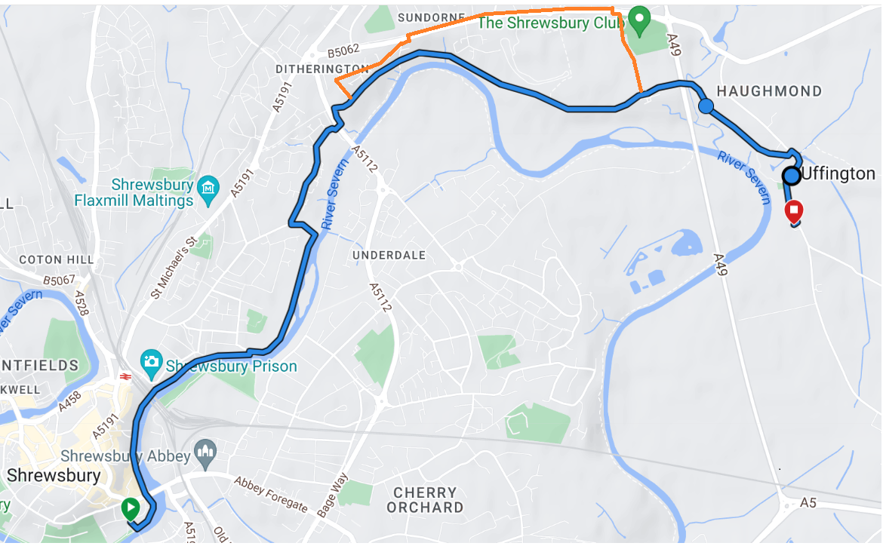

ROUTE MAP; RETURN JOURNEY APPROXIMATELY 8 MILES. With alternative route in orange
Hazard | Risk  (low = 1, medium =2, high = 3) |  | Severity of outcome (low = 1, medium =2, high = 3) | Total grade of hazard (= risk x severity). NB if total is 9, hazard must be removed or avoided | Location |  | Warning, Control measures and/or alternatives considered
Rider’s health/SEND/Disability/  inexperience | 2 |  | 3 | 6 |  |  | Close support by able bodied riders (1 to 1 if necessary).  Use of suitable adaptive bikes and tandems. Matching of riders to bikes in advance of ride. Provision of back up vehicle.
Equipment/bike safety | 2 |  | 3 | 6 |  |  | Cycles will be selected according to the rider’s height, weight and abilities and saddle heights set appropriately. C4all equipment to be checked by a member of the maintenance team before the ride. All riders should M check their own equipment. Tyres will be assessed to ensure adequate and even pressure. Mobile phones and first aid carried. Helmets and hi viz to be worn.
Rider going too fast | 2 |  | 3 | 6 |  |  | Ride Leaders should monitor the riders speed and handling at all times and should avoid distractions. Pace to suit all riders set by front ride leader.
Traffic free cycle route shared with other cyclists, walkers and dog walkers travelling in both directions. Potential for collision. | 2 |  | 2 | 4 |  |  | Ride safety briefing given before start. Advised to share with care. Pedestrians to be given priority. Close supervision and ride leadership by C4A. No significant hills. Stop to avoid collisions if the route becomes crowded.
Group getting split | 1 |  | 1 | 1 |  |  | Make all familiar with route before ride starts and agree early meet up location e.g. the weir
Junctions and right turns on road section including where path joins Church Rd at Uffington. | 2 |  | 3 | 6 | Newpark Road/Millers Green/Church Road |  | Single bike ride leader to cover junctions plus marshal suitably positioned to check road clear to enter if required.
Gravel/muddy cycle path. | 2 |  | 3 | 6 | Mainly section by old canal |  | Close supervision/appropriate speed set by leader. Advanced warnings by ride leader.
Nearby river and canal. | 1 |  | 3 | 3 |  |  | Ride leaders to closely supervise and take a route well clear.  Emergency buoyancy aids are located at intervals along the route.
Car park at Pub | 1 |  | 3 | 3 | Corbet Arms, Uffington |  | Riders advised to take care in pub car park and when leaving bikes outside of pub.
Limited facilities – toilets, cafes, shops. | 1 |  | 3 | 3 |  |  | Use of Sports Village/Corbett Arms Pub if needed. Emergency arrangements in place.
Narrow lanes / alley | 1 |  | 2 | 2 | Housing estate alley, Millers Grn and as you come out of the forest area to Church Road. |  | Ride single file, slowly with care.  Use bell to warn your approach.
Under road tunnels | 2 |  | 3 | 6 |  |  | Ride single file, slowly with care Use bell to warn your approach..
Cobbled stones under Shrewsbury train station bridge. | 2 |  | 3 | 6 | Railway bridge |  | Do not cycle when wet or icy.
Tree roots | 2 |  | 2 | 4 | Canal area |  | Cycle over with care or stop and walk round.
Tree branches and brambles. | 2 |  | 2 | 4 |  |  | Stop and remove branches from cycle way. Avoid cycling over brambles to avoid punctures.
The cycle way under the English Bridge has a low arch warning. | 2 |  | 2 | 4 | English Bridge |  | Be observant of the arch and other users of the passage.
Low hanging branches in the forested areas. | 2 |  | 2 | 4 | Forest areas |  | Be observant of low hanging branches.
Wildlife | 1 |  | 2 | 2 | Forest and river areas |  | Wildlife such as ducks and swans live along the route. Avoid or stop to walk around them
Post and bollards | 2 |  | 2 | 4 |  |  | There are a number of post and bollards. Be very mindful and observant. Navigate around.
Tight bends | 2 |  | 3 | 6 | By Telford Way underpass |  | The route has some tight bends. Ride single file, slowly with care. Use bell to warn approaching.
Pot holes | 2 |  | 3 | 6 |  |  | Avoid or walk over.
Wet leaves | 2 |  | 3 | 6 |  |  | Slippery surface. Avoid, cycle with care or walk over.
Tarmac or paving edges. | 2 |  | 3 | 6 |  |  | Avoid, cycle with care or walk over.
Dark shaded areas and glare. | 2 |  | 3 | 6 | Canal area |  | Be mindful of dark shaded areas even on a bright sunny day. Sun glare through the trees is also an issue.  Be observant and take care. Walk if necessary.
The route has short ascent and descents. | 2 |  | 3 | 6 | Canal area mainly. |  | Take care and choose the appropriate cycle gear before you approach the change in gradient.
Puddles | 2 |  | 2 | 4 |  |  | Avoid or take care.
Railings | 2 |  | 2 | 4 | Along river |  | The route has railings particularly along the river. Be mindful and observant of them.
Walls | 2 |  | 2 | 4 | Along river |  | Along the river are high brick walls. Avoid cycling too close to them as surfaces can be uneven and have protrusions
Road junctions | 2 |  | 3 | 6 | Church Road, Uffington |  | Particular care is needed when leaving the canal track to the road. Check left and right down the road to ensure the way across the road is clear. An observer on the opposite across of the road with a better view is desirable. If using alternative route via Sundorne Rd particular care must be taken when crossing the road.
Cold, hot and wet weather | 2 |  | 3 | 6 |  |  | All must wear appropriate clothing.
Safeguarding | 2 |  | 3 | 6 |  |  | Any under 18’s they must have a parent or guardian with them.
Conflict with other path and Road users | 2 |  | 2 | 4 |  |  | All should not react to cause provocation.  C4AS representatives should aim to calm any situation down. If the situation is not controllable the police should be contacted.
Riders getting lost. | 2 |  | 3 | 6 |  |  | Ride leaders must know the route. The group must have a back marker who also knows the route. The back marker should have phone communication to the ride leaders in the event of an incident.
Ride Leaders | 2 |  | 3 | 6 |  |  | All ride leaders to be leadership trained and cycled this route. All leaders must read the route risk assessment before a ride.

EVENT METHOD STATEMENT

- Arrive at start point and move cycles and equipment into allocated area. Take care re unloading.
- Check the weather conditions for the ride are safe.
- Check all riders have signed the ride log.
- Check all non-trained riders have signed a disclaimer are wearing hi viz and have been strongly encouraged to wear a helmet.
- Check all ride leaders have appropriate training.
- Check all ride leaders have read and understood the risk assessment for the route.
- Check all cycles are road worthy and have been maintained. Tyres, bells, mirrors etc., etc.
- Match riders to cycles and make adjustments e.g. saddle height, handlebar position as required.
- Move vehicle/s to appropriate parking areas
- Provide opportunity for short cycle test ride using safe area and under supervision.
- Issue safety briefing
- Proceed with ride and follow any Risk Assessment guidance.
- If pub stop, ensure bikes and equipment kept safe and secure. Consider accessibility of pub and help riders if needed.
- On return, load cycles and equipment into vehicles with care and use good manual handling techniques.
- At the end of the ride ensure all incidents are recorded on the incident log.

