Safeguarding Report Form (Confidential)

Designated Safeguarding Lead: ………………………………
Contact Details : …………………………Tel: ………………………………………….
This form must be completed in the event of any of the following cases:
● Whenever a child or vulnerable adult makes a disclosure
● To report on significant harm done towards a child or vulnerable adult by a volunteer

Liaise with the C4AS Designated Safeguarding Lead (DSL) when completing the form.
The form must be completed within 24 hours of the disclosure or observation made
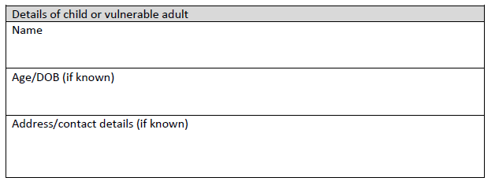
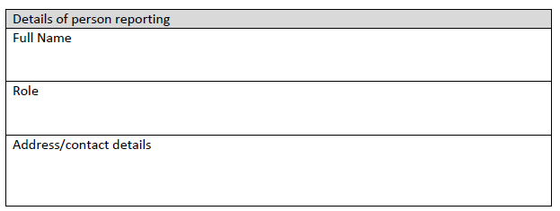
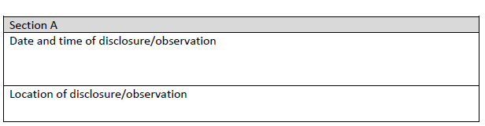
Other persons present

